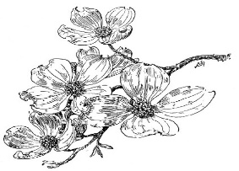
Warm Scones
Tea at the Inn
Served with Apple Butter, Lemon Curd, and Pumpkin Spice Cream
Savory
Smoked Mummy Sausages
Smoked Salmon Pinwheel
Cucumber Boursin Sandwich
Bloody Mary Bisque
Brie and Cranberry
Sweet
Caramel Macaron Pumpkins
White Chocolate Beet Sorbet
Candy Corn Mousse
Franken-pear Petit Fours
Chocolate Tombstone Tarts
Halloween Time Tea $34

Sparkling Halloween Time Tea $40
Includes a Glass of Sparkling Wine

Sparkling Wine by the Glass
LaMarca Prosecco, IT NV 14
Charles de Cazanove, Champagne, FR NV 20

Fine Loose-Leaf Tea Selections
Black Tea - Emperor’s Breakfast. A blend of three teas from the world’s most renowned origins - Assam, Darjeeling and Yunnan, resulting in an English Breakfast tea that is equally interesting and familiar.

Earl Grey – Cremé. A spin on the classic Earl Grey tea. This distinctive, flavored black tea rounds out its crisp bergamot notes with a gentle creamy character.

Green Tea - Three Rivers Green. This whole leaf green tea grown high in the Yunnan mountains yields a mild nutty flavor with subtle fruit undertones.

Black Tea - Darjeeling Estate. A black tea sourced from the finest plantations in Darjeeling, India. These silver-tipped black tea leaves yield a fruity and floral flavor resulting in an aromatic and memorable cup.

Fruit - African Nectar. Rooibos is an herbal plant from South Africa. African Nectar is a caffeine free blend teeming with tropical fruit and blossoms. It promotes calm and relaxation.

